# Class Diagram

## 3.6.1. Class Diagram for Admin

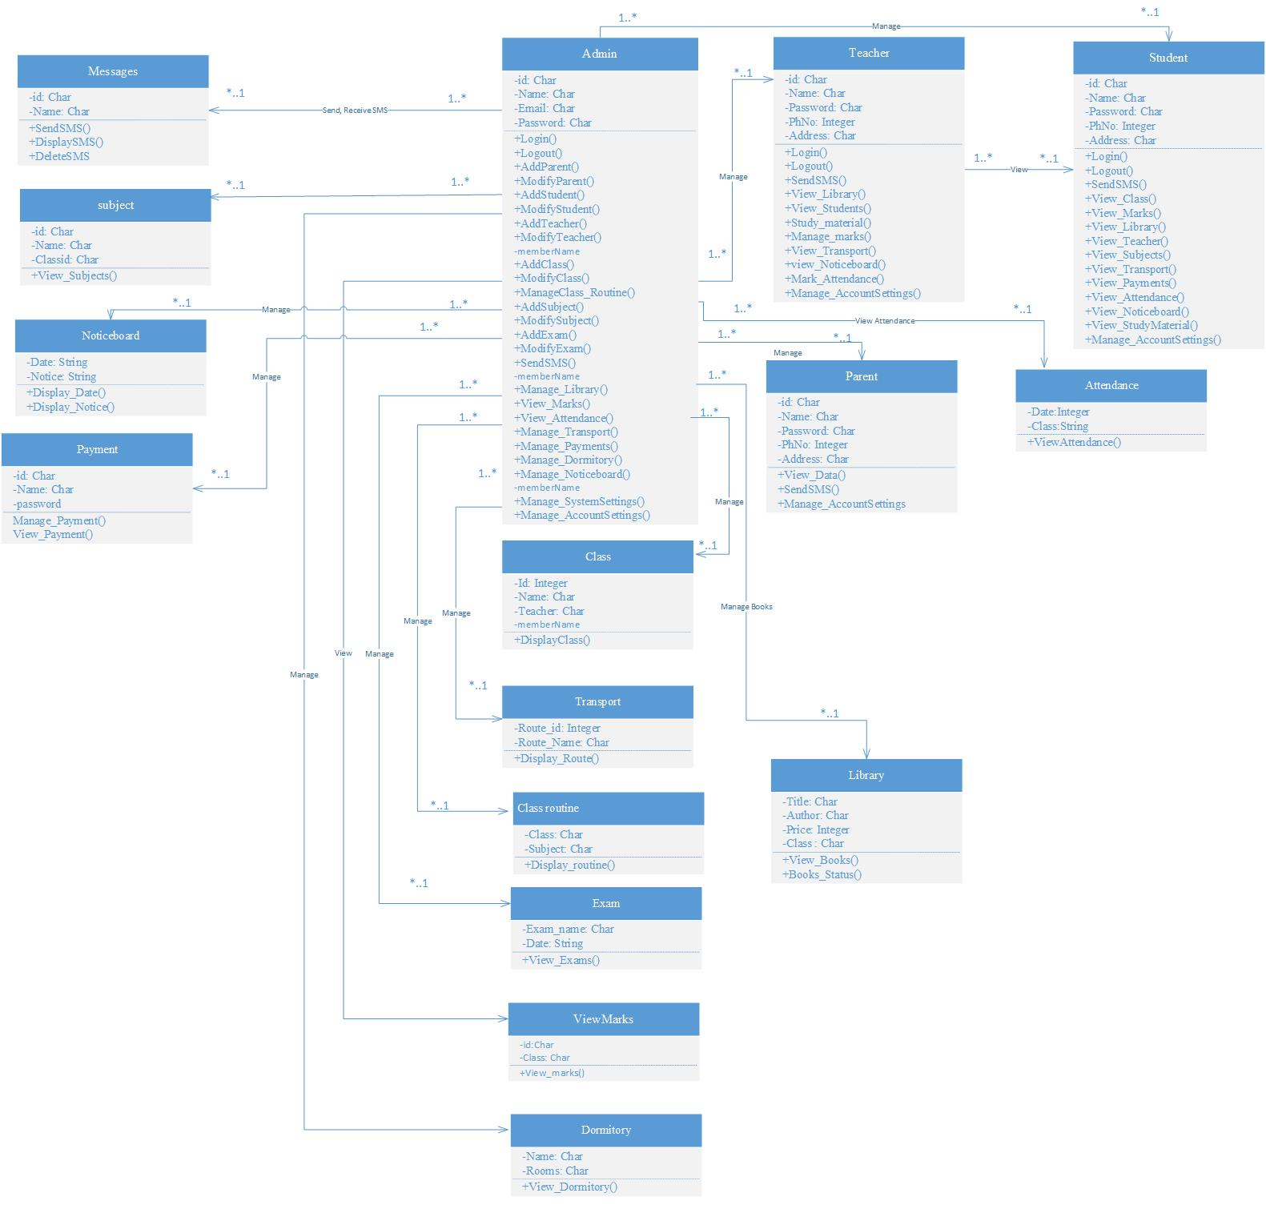

## 3.6.2. Class diagram for Teacher

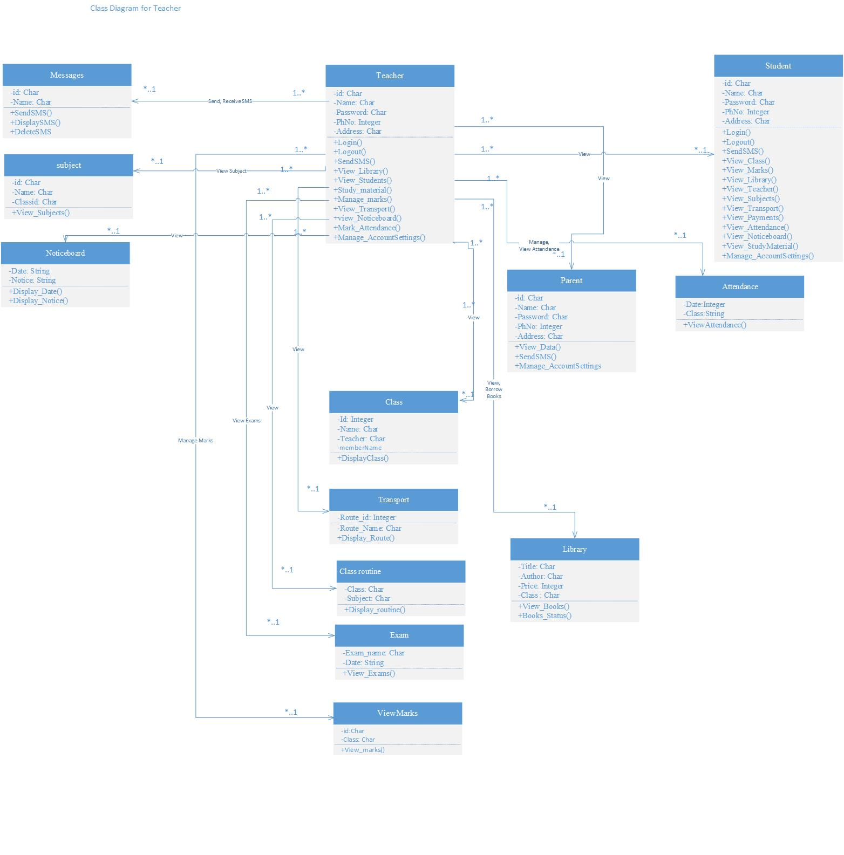

## 3.6.3.Class diagram for Student

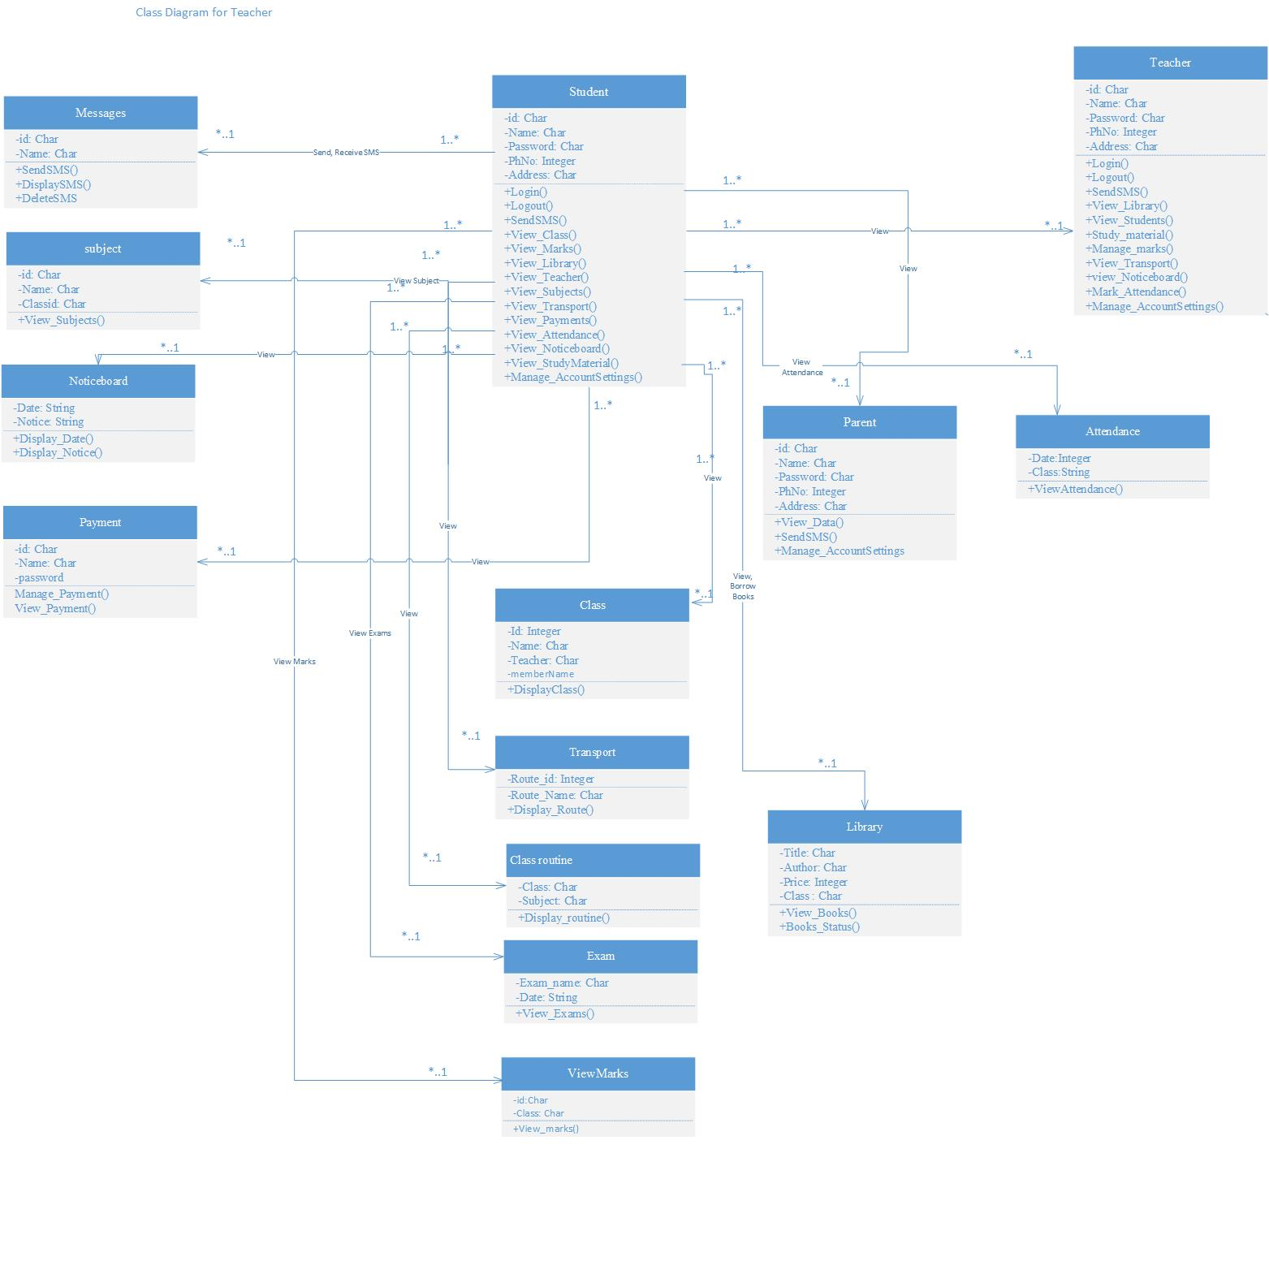

## 3.6.4. Class diagram for Parent

